Lab: Configuring the Capacity Scheduler
Objective: | Learn how to define and configure queues for the Capacity Scheduler.
Successful Outcome: | You will have two new queues configured.
Before You Begin: | Your cluster should be up and running.

- View the Status of the Capacity Scheduler
  - Point your web browser to http://localhost:8088 to view the UI of the Resource Manager.
  - In the menu on the left side, click on the Scheduler link to view the current status of the Capacity Scheduler:
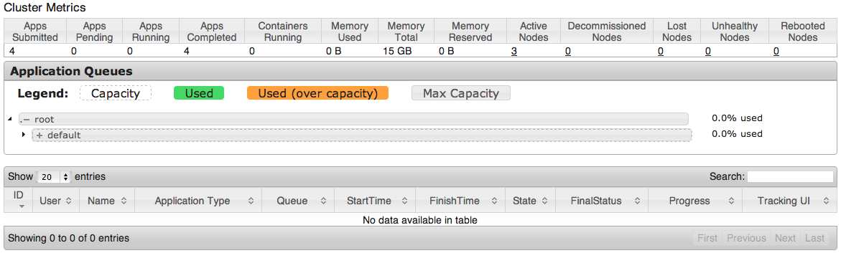
  - Notice there is one child queue of root defined. What is the name of the queue? _________________
  - Click on the arrow to the left of “default” to expand and view the settings of the default queue:
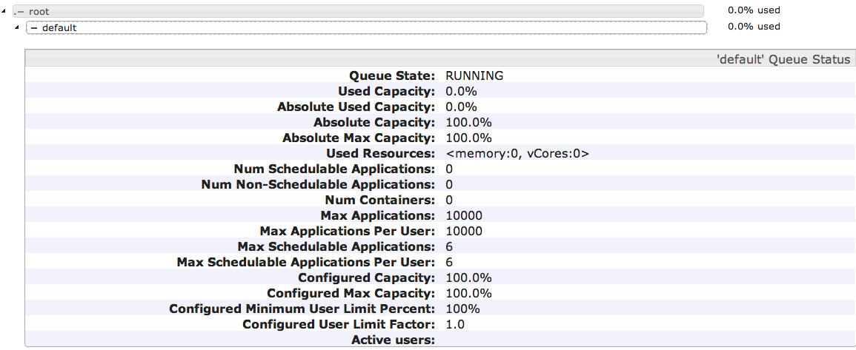
  - Notice since there are no jobs running on your cluster, the status page simply shows 0.0% of default is being used right now.
- View the Settings of the Capacity Scheduler
  - Go to the Ambari Dashboard page (port 8080).
  - Click on the YARN link in the list of services, then click on the Configs tab and scroll down to the Scheduler section:
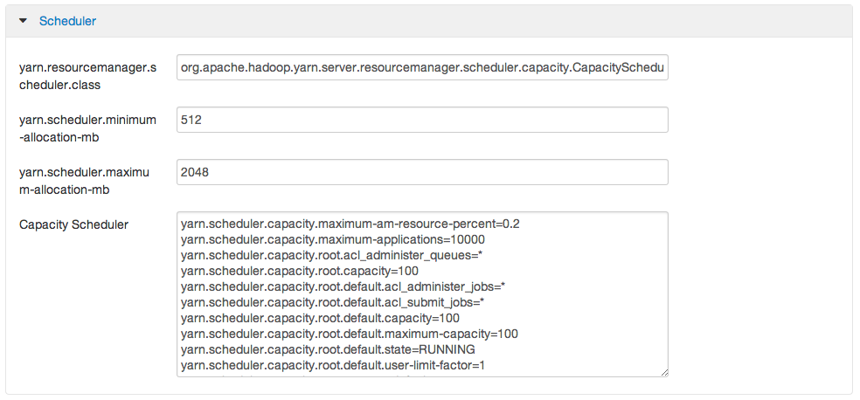
  - Notice this is where you configure the settings for the scheduler of the Resource Manager. Which type of scheduler is currently being used? ________________________________________
- Define Custom Queues
  - From the Configs tab of the YARN Services page, add two new queues named A and B to the Capacity Scheduler (and leave the default queue defined also):
yarn.scheduler.capacity.root.queues=default,A,B
  - Assign the following capacities to the three queues:
default capacity = 20%
A capacity = 50%
B capacity = 30%
  - Assign the following maximum capacities to the three queues:
default maximum capacity = 100%
A maximum capacity = 70%
B maximum capacity = 50%
  - Save your changes by clicking the Save button at the bottom of the page. You should see the following confirmation dialog:
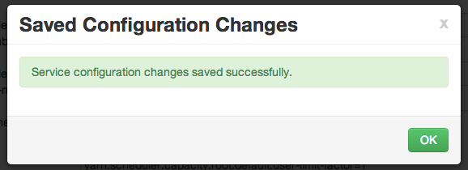
  - Click OK to close the dialog window.
- ReStart YARN
  - Go back to the Summary page of YARN and click the Start button to start the YARN service again.
- Verify the Changes
  - Go back to the Scheduler web page at http://[localhost]:8088/cluster/scheduler.
  - You should see the A and B queues now:
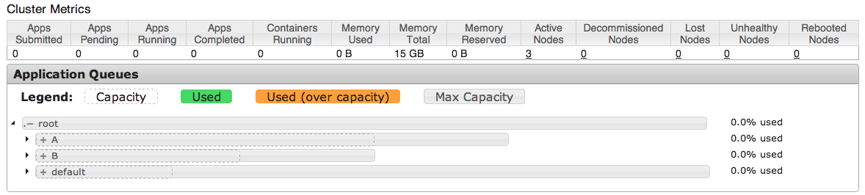
  - Expand the A queue and verify its capacity is 50% and its maximum capacity is 70%:
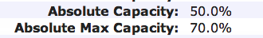
  - Similarly, verify B and default are configured correctly.
  - Leave this web page open - you are going to view it in the next step.
- Submit a Job to a Specific Queue
  - Let’s submit a MapReduce job to each new queue. SSH into hadoop-master, and change directories to the /root/labs folder:
[root@node1 ~]# cd ~/labs
  - Make sure environment variable JAVA_HOME is defined, so enter the following command:
# export JAVA_HOME=/usr/jdk64/jdk1.6.0_31/
  - Make sure you have a file in /user/root in HDFS named hbase.jar. If not, put the HBase jar from the labs folder into HDFS, giving it the name hbase.jar.
  - In the first window, submit the test1.pig script to queue A by running the following command (all on a single line):
# pig -Dmapreduce.job.queuename=A test1.pig 1>pig1.out &>pig1.err &
  - While test1.pig is running, submit the test2.pig script to queue B in the other terminal window:
# pig -Dmapreduce.job.queuename=B test2.pig 1>pig2.out &>pig2.err &
  - While both jobs are running, refresh the Scheduler status page. (It may take a minute for both jobs to run long enough to show up in the queues, so refresh the page often until they do):
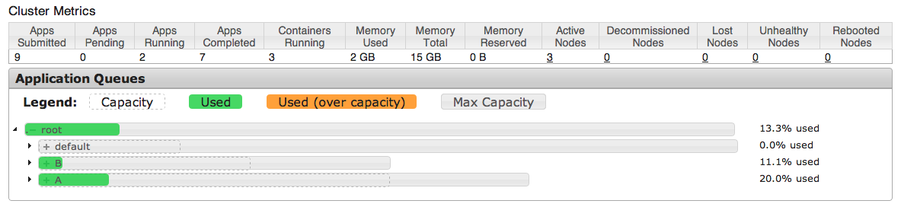
  - You should see resources being used in both the A and B queues.

RESULT: You just defined two queues for the Capacity Scheduler, configured specific capacities for each queue, and submitted a job to each queue.

ANSWERS:
1.3: default
2.3: The Capacity Scheduler

